

1. **Sports and hobbies -** simple present Write down what they do after school.

1 Kim **watches TV**. 2 Tony **plays the guitar**.

1. Kevin **listens to music**. 4 Jane **reads a book / reads books**.

5 Mike **teaches the dog** / Bonzo (some/ a lot of) **tricks**.

1. 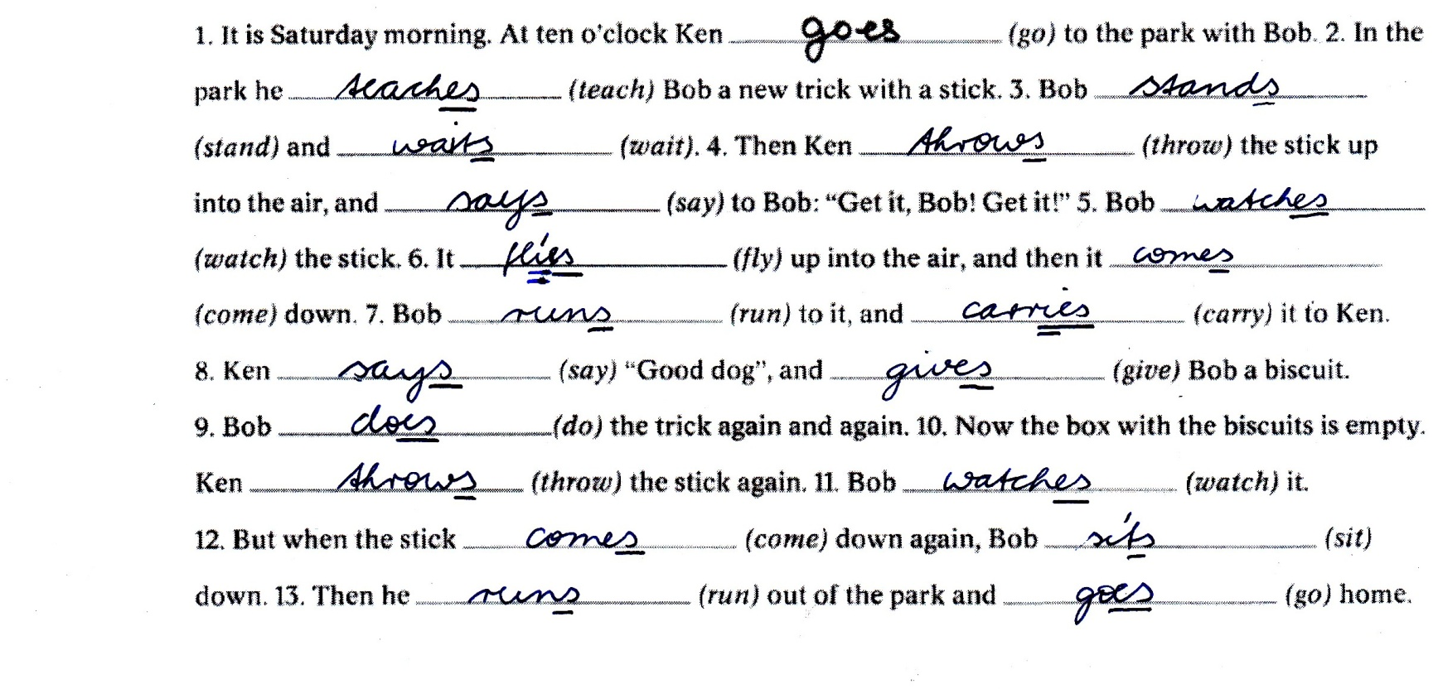**The trick with the stick** *Fill in the correct form of the verbs.*

• fly → it fl**ie**s ► y zwischen 2 Konsonanten → ie

• say → he s**ay**s ► y zwischen Vokal+ Konsonanten → y

1. **SIMPLE PRESENT** - **positive statements + Bonzo the dog**

**6 WORD ORDER**  Satzstellung Put the words in the right order.

1 Mrs Croft always goes to work at 9 o’clock.

↓ ↓ ↓ ↓ ↓

subject ↓ predicate place time = SP(O) + place + time

adverb of frequency

2 Becky often takes Benny to the park on Saturday.

↓ ↓ ↓ ↓ ↓ ↓

subject ↓ predicate object place time

adverb of frequency

3 Simon never plays football in the park.

↓ ↓ ↓ ↓ ↓

subject ↓ predicate object place

adverb of frequency

**7 WORD ORDER**  What they do. *Write sentences.*

2 Mandy **sometimes** go**es** swimming.

3 Mr Black **often** eat**s** fish.

4 Tom **sometimes** do**es** tricks.

5 Sandra **never** play**s** football.

6 Mrs Benn **often** go**es** to Londo.